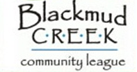
Safety Orientation Acknowledgement Form

I _______________________________ (print name) confirm that I received a Basic Safety and Security Orientation for carrying out the work of a rink attendant at the Allard Rink, and fully understand the content of the orientation. I confirm that I have also received detailed hands-on training of how to safely operate all gas powered equipment at the Allard Rink.
I hereby agree to abide by all of the safety and security rules and regulations. I understand that the violation of these rules and regulations may result in disciplinary action or the loss of working privileges with the Blackmud Creek Community League.

Employee’s or Volunteer’s Signature: _______________________________
Date: _______________________________

Instructor’s Signature: _______________________________
Date: _______________________________

